Dhmaodaran G - Performance Report

This report provides detailed insights into performance by topic, subtopic, and learning fundamentals.

# Learning Fundamentals

Listening: 97.90%

Grasping: 0.00%

Retention: 0.00%

Application: nan%

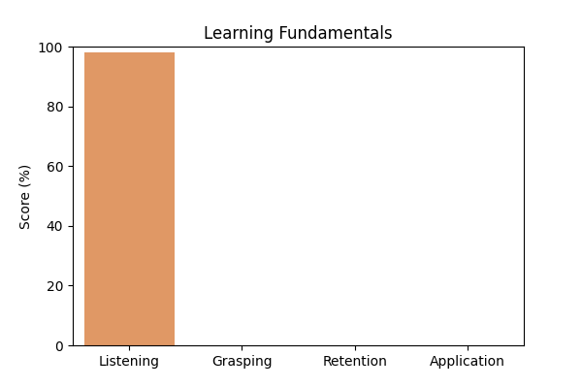

# Topic Accuracy

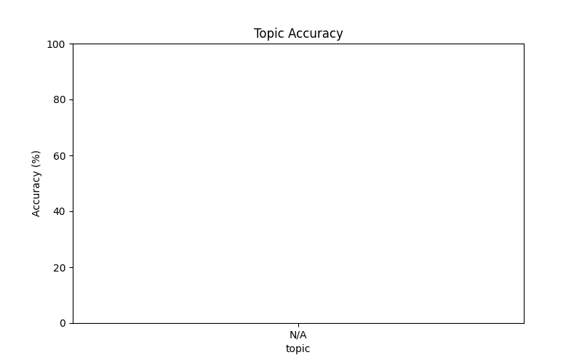

# Subtopic Accuracy

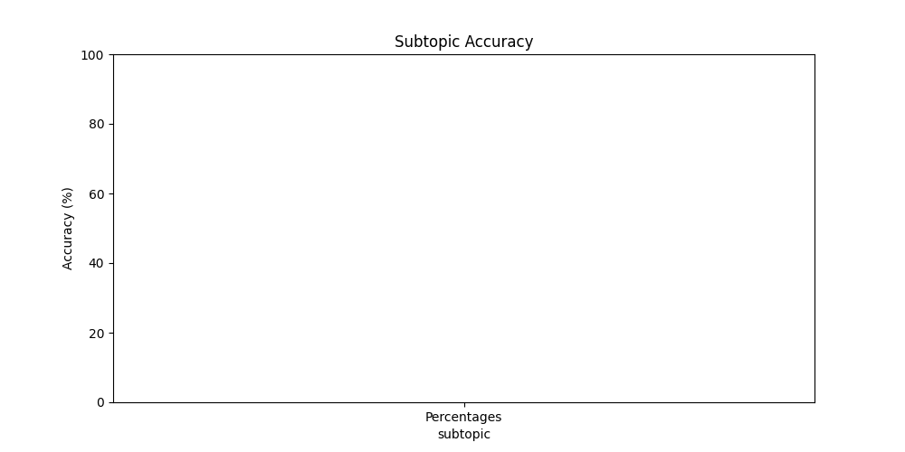

# Result Analysis

Total Questions: 10

Correct Answers: 0

Incorrect Answers: 10

Average Time per Question: 2.10 seconds

# Question-wise Performance

Q: 3.5 can be expressed in terms of percentage as:  
Topic/Subtopic: N/A / Percentages  
Your Answer: b | Correct Answer: d | ❌ Incorrect | Time Taken: 1.97s

Q: Half of 1 percent written as a decimal is:  
Topic/Subtopic: N/A / Percentages  
Your Answer: b | Correct Answer: a | ❌ Incorrect | Time Taken: 1.86s

Q: 40% of 1640 + ? = 35% of 980 + 150% of 850  
Topic/Subtopic: N/A / Percentages  
Your Answer: b | Correct Answer: c | ❌ Incorrect | Time Taken: 2.42s

Q: 60% of 264 is the same as:  
Topic/Subtopic: N/A / Percentages  
Your Answer: a | Correct Answer: b | ❌ Incorrect | Time Taken: 1.81s

Q: What percent of 7.2 kg is 18 gms?  
Topic/Subtopic: N/A / Percentages  
Your Answer: a | Correct Answer: b | ❌ Incorrect | Time Taken: 1.97s

Q: 0.01 is what percent of 0.1?  
Topic/Subtopic: N/A / Percentages  
Your Answer: a | Correct Answer: b | ❌ Incorrect | Time Taken: 3.55s

Q: What percent of Rs. 2650 is Rs. 1987.50?  
Topic/Subtopic: N/A / Percentages  
Your Answer: c | Correct Answer: b | ❌ Incorrect | Time Taken: 1.61s

Q: What percent of day is 3 hours?  
Topic/Subtopic: N/A / Percentages  
Your Answer: b | Correct Answer: a | ❌ Incorrect | Time Taken: 0.0s

Q: Which one of the following shows the best percentage?  
Topic/Subtopic: N/A / Percentages  
Your Answer: c | Correct Answer: b | ❌ Incorrect | Time Taken: 2.87s

Q: 5% of (25% of Rs.1600) is:  
Topic/Subtopic: N/A / Percentages  
Your Answer: d | Correct Answer: c | ❌ Incorrect | Time Taken: 2.97s

# AI Analysis

Engagement and performance metrics provide insight into overall academic progress. Topics requiring further attention include: N/A. Areas that may benefit from additional practice: Percentages. Overall accuracy: 0.00%, Average time per question: 2.10s. Maintaining consistent effort and reviewing challenging topics will lead to better outcomes.